# Organic-Shop Code Architecture

Here the commponents guarded by AdminauthGuard service. Only admin user can enter to them.

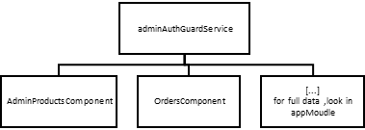

Here the commponents guarded by authGuard service. Only login user can enter to them.

